




School: ............................................................................................................. Campus: .......................................................

Academic Year: ...................... Subject Name: ........................................................... Subject Code: ..........................

Semester: ............... Program: ........................................ Branch: ......................... Specialization: ..........................

Date: .....................................

(Learning by Doing and Discovery)
Creating one design using Figma

Coding Phase: Pseudo Code / Flow Chart / Algorithm

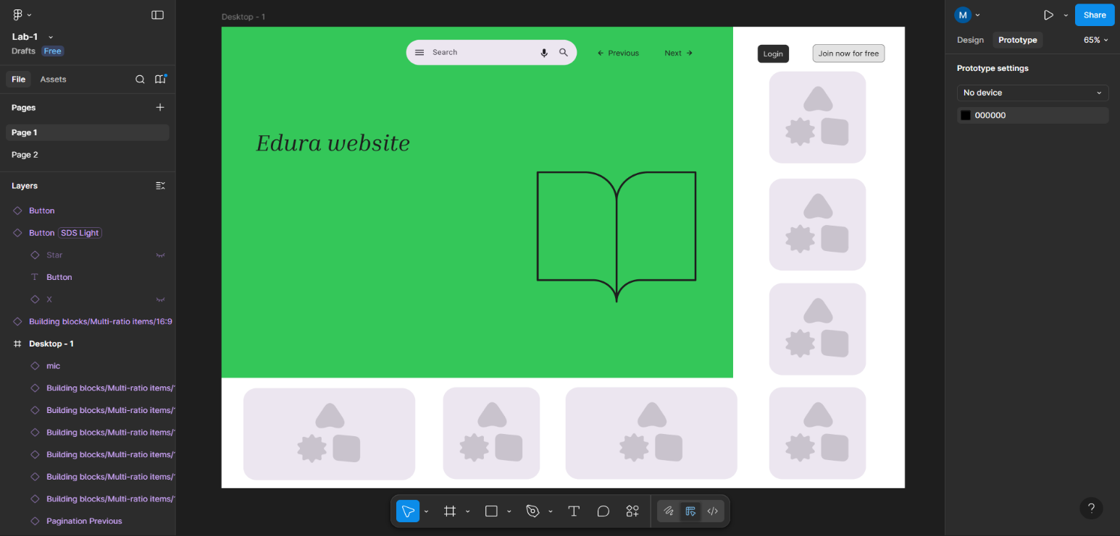
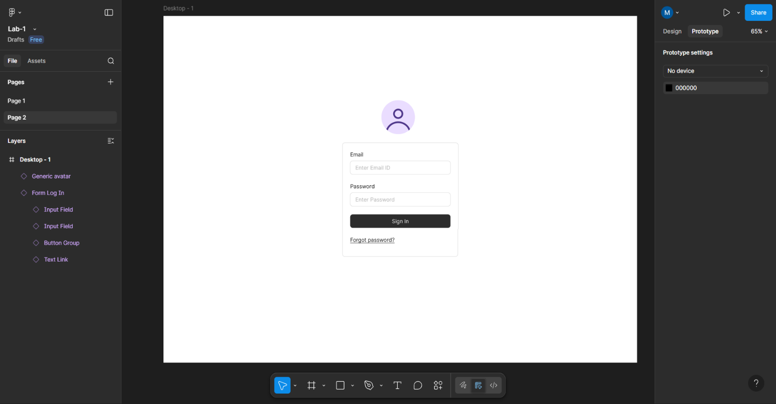

- Testing Phase: Compilation of Code (error detection)

No Error

* Implementation Phase: Final Output (no error)
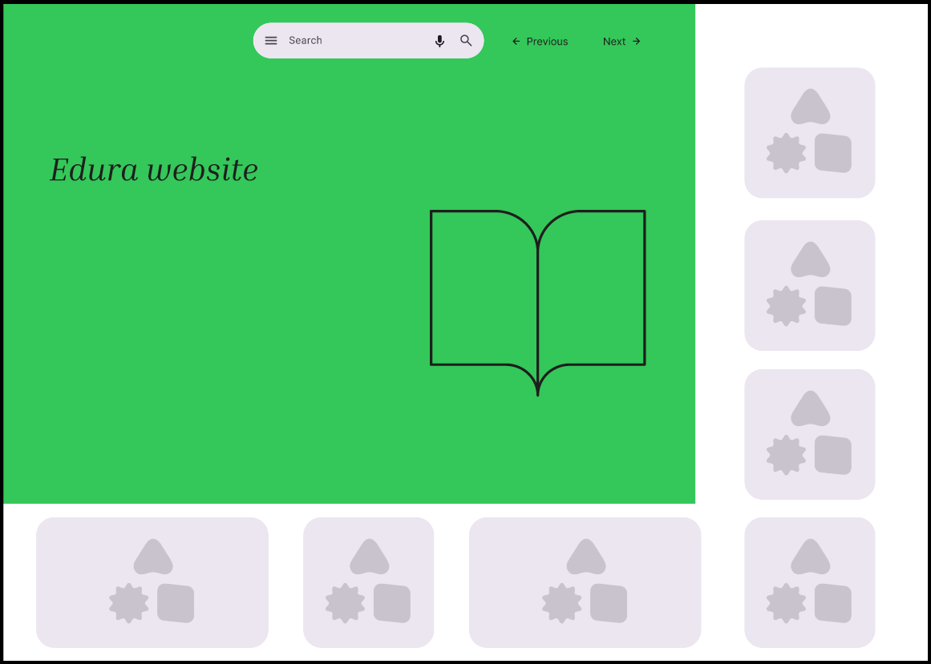

Rubrics
Concept | 10
Planning and Execution/  Practical Simulation/ Programming | 10
Result and Interpretation | 10
Record of Applied and Action Learning | 10
Viva | 10
Total | 50
Signature of the Student:
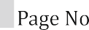
Signature of the Faculty:

